

Sem 1 Examination 2015

Question/answer booklet

MATHEMATICS
APPLICATIONS
UNIT 1

Section One:
Calculator-free
Name:

Teacher:

Time allowed for this section
Reading time before commencing work: 5 minutes
Working time for paper: 50 minutes

Material required/recommended for this paper

To be provided by the supervisor
This question/answer Booklet
Formula sheet

To be provided by the candidate
Standard items: pens, pencils, pencil sharpener, eraser, correction fluid/tape, ruler, highlighter

Standard items: nil

Important note to candidates
No other items may be taken into the examination room. It is your responsibility to ensure that you do not have any unauthorised notes or other items of a non-personal nature in the examination room. If you have any unauthorised material with you, hand it to the supervisor before reading any further.

Structure of this paper

Section | Number of questions available | Number of questions to be answered | Working time  (minutes) | Marks  available | Percentage  of exam
Section One:  Calculator-free | 6 | 6 | 50 | 50 | 35
Section Two:  Calculator-assumed | 13 | 13 | 100 | 100 | 65
 |  |  | Total | 150 | 100

Instructions to candidates

- The rules for the conduct of Western Australian examinations are detailed in the Year 12 Information Handbook. Sitting this examination implies that you agree to abide by these rules.

2. Write your answers in the spaces provided in this Question/Answer Booklet. Spare pages are included at the end of this booklet. They can be used for planning your responses and/or as additional space if required to continue an answer.
  - Planning: If you use the spare pages for planning, indicate this clearly at the top of the page.
  - Continuing an answer: If you need to use the space to continue an answer, indicate in the original answer space where the answer is continued, i.e. give the page number. Fill in the number of the question(s) that you are continuing to answer at the top of the page.

3. Show all your working clearly. Your working should be in sufficient detail to allow your answers to be checked readily and for marks to be awarded for reasoning. Incorrect answers given without supporting reasoning cannot be allocated any marks. For any question or part question worth more than two marks, valid working or justification is required to receive full marks. If you repeat an answer to any question, ensure that you cancel the answer you do not wish to have marked.

4. It is recommended that you do not use pencil except in diagrams.

MARK ALLOCATION AND RECORDS:

Section | Question | Marks | Awarded
ONE | 1 | 5
ONE | 2 | 17
ONE | 3 | 3
ONE | 4 | 6
ONE | 5 | 7
ONE | 6 | 12
 | ONE | 50
 | TWO | 100
 | TOTAL | 150 |  |  | %

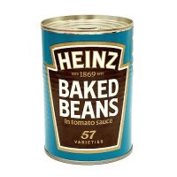
1. (5 marks)
A factory manufactures cans of Baked Beans. Each can has a radius of 4 cm and a height of 12 cm.
(a) A paper label is designed to wrap around the can.

Find the area of the paper label in terms of π. (2 marks)

Each can of Baked Beans is almost full and goes up to 97% of the height of the can.
(b) Write down an expression which when evaluated would give you the volume of the Baked Beans. (3 marks)

2. (17 marks)
(a) Consider the following matrices
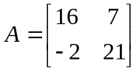, 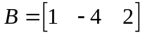, 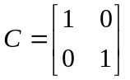, 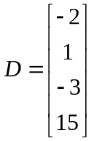, 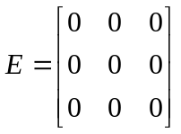
Select a matrix that fits the descriptions below, but do not choose the same
matrix twice. Write down the size of each matrix you select.

Matrix Size

(i) Column matrix _____ ___________ (2 marks)

(ii) Identity matrix _____ ___________ (2 marks)

(iii) Row matrix _____ ___________ (2 marks)

(iv) Zero matrix _____ ___________ (2 marks)

(v) Square matrix _____ ___________ (2 marks)

(b) Calculate the following
(i) 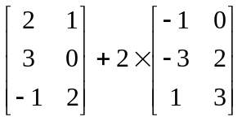 (2 marks)

Continued next page.

Question 2 (continued).
(ii) 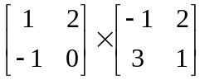 (2 marks)

(c) Show that the product of 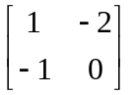 and 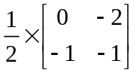 gives the identity matrix.
(Full working needs to be shown.)
(3 marks)


3. (3 marks)
A 650 gram box of cornflakes costs $5.80.
A 500 gram box of the same brand of cornflakes costs $5.

Which box is relatively the cheaper? (3 marks)

(Show all reasoning)

4. (6 marks)

(a) Explain carefully why the following pairs of triangles are similar.
(i) (3 marks)
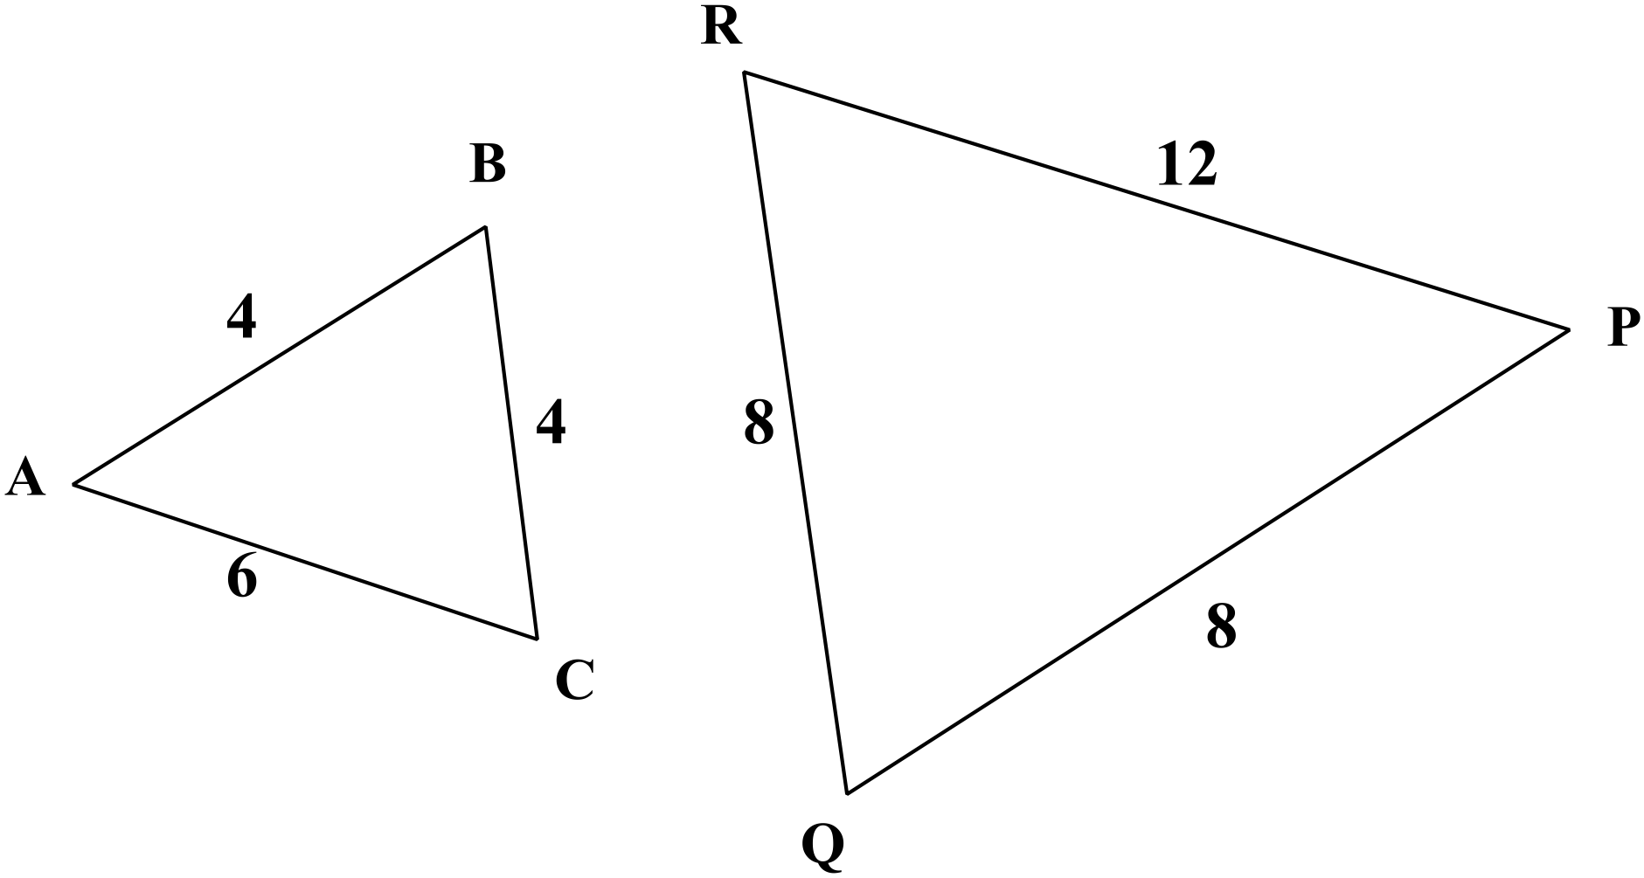

(ii) (3 marks)
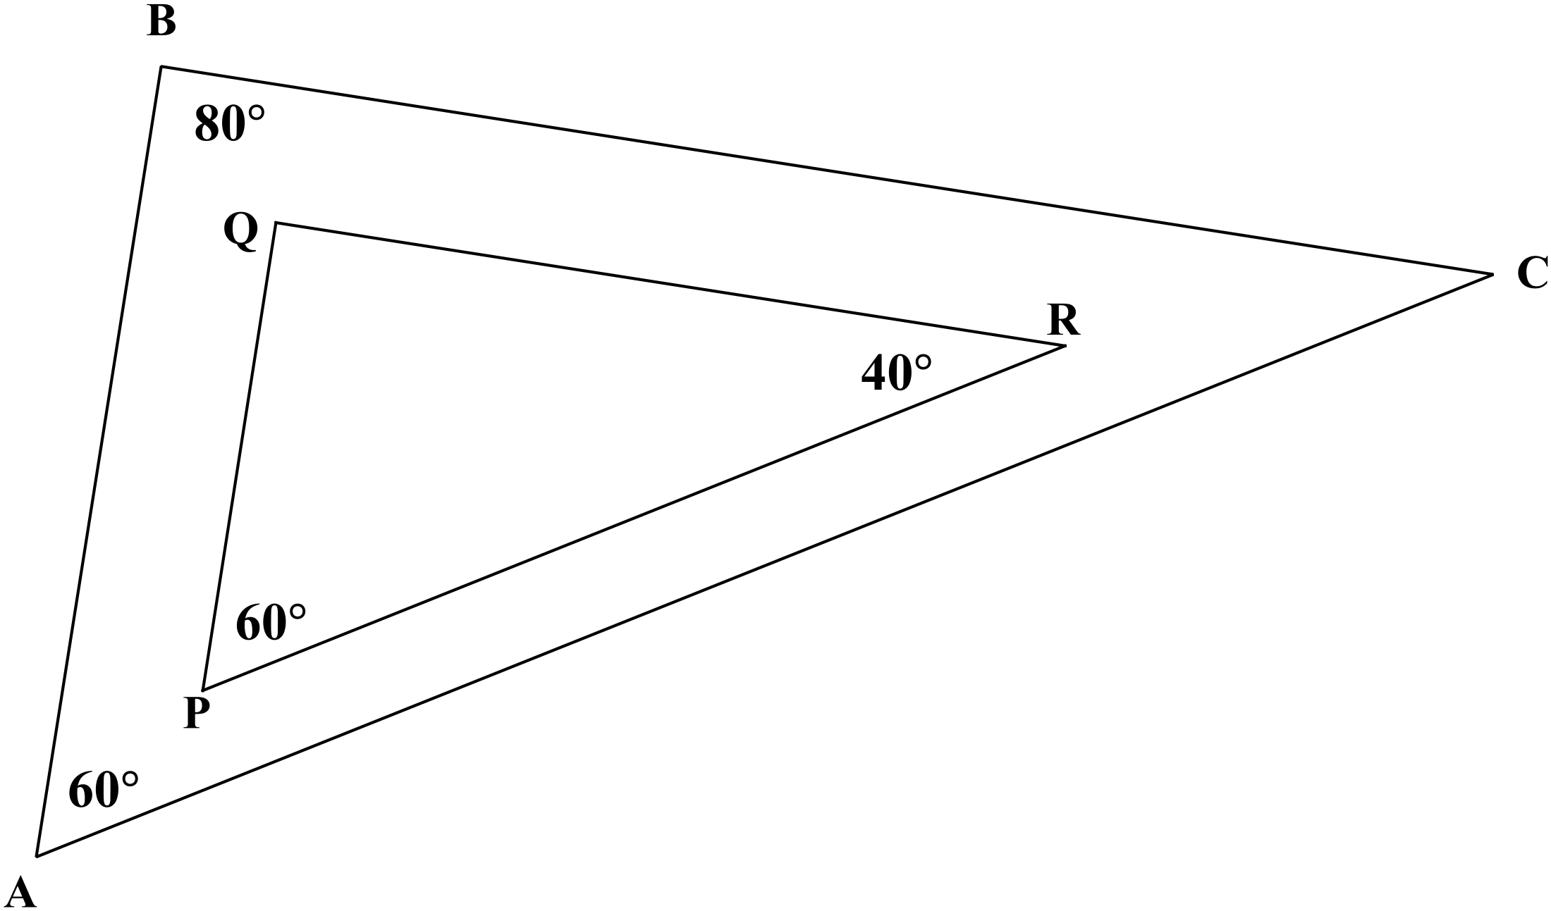

5. (7 marks)
A communication network between three friends A, B and C is shown below.
The arrows show the direction of the communication. A line with only one arrow means that the communication goes only one way.
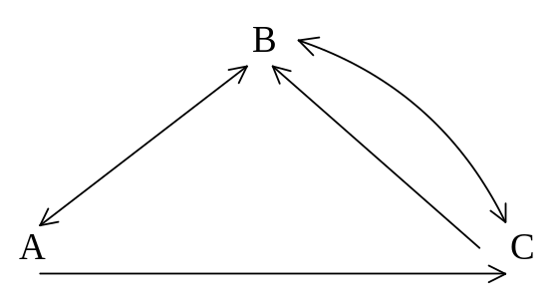
(a) Complete the communication matrix X below: (2 marks)
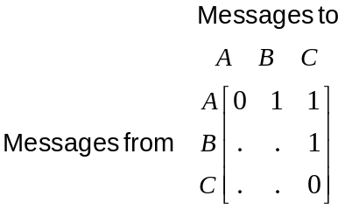

(b) Which person cannot communicate directly with which other person? (1 marks)

Continued next page.

Question 5 (continued).

If a message goes via someone else first, then arrives, the communication matrix is a 2 stage matrix and is represented as 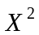.

(c) Complete the matrix that represents the two stage communication matrix.

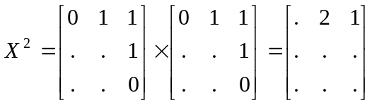 (3 marks)

(d) Explain the meaning of the 2 in in row 1, column 2. (1 mark)

6. (12 marks)
Marianne has just bought 10 000 shares in ABC Holdings at $0.80 each.
(a) If Marianne is paid $0.08 per share in dividends during the next financial year, how much will she receive? (2 marks)

(b) What percentage does this dividend represent of the price of the shares?
(2 marks)

The Price to Earnings ratio (PE) is defined as 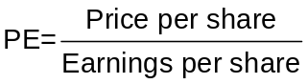.
PE is a measure of comparison between the value of shares over the earnings made from the shares.

(c) Calculate the PE ratio for ABC Holdings. (2 marks)

.

Continued next page.

Question 6 (continued).

Another company, PQR Mining, has a PE of 7.5.
(d) Which company represents the best buy based on PE ratios? Explain. (2 marks)

(e) (i) Ignoring dividends, how much will Marianne have made on her shares if
in 6 months time they are valued at $1 each? (2 marks)

(ii) Comment on any other costs incurred when buying shares that must be
taken consideration. (2 marks)

END OF SECTION ONE

Extra page for working if necessary

Extra page for working if necessary

Extra page for working if necessary

Extra page for working if necessary

